**Responsive Assignment**

The site I’ll be using as my case study is “**Spotify**” <https://www.spotify.com/sl/> it a responsive website that can change according to your device

***Desktop View:***

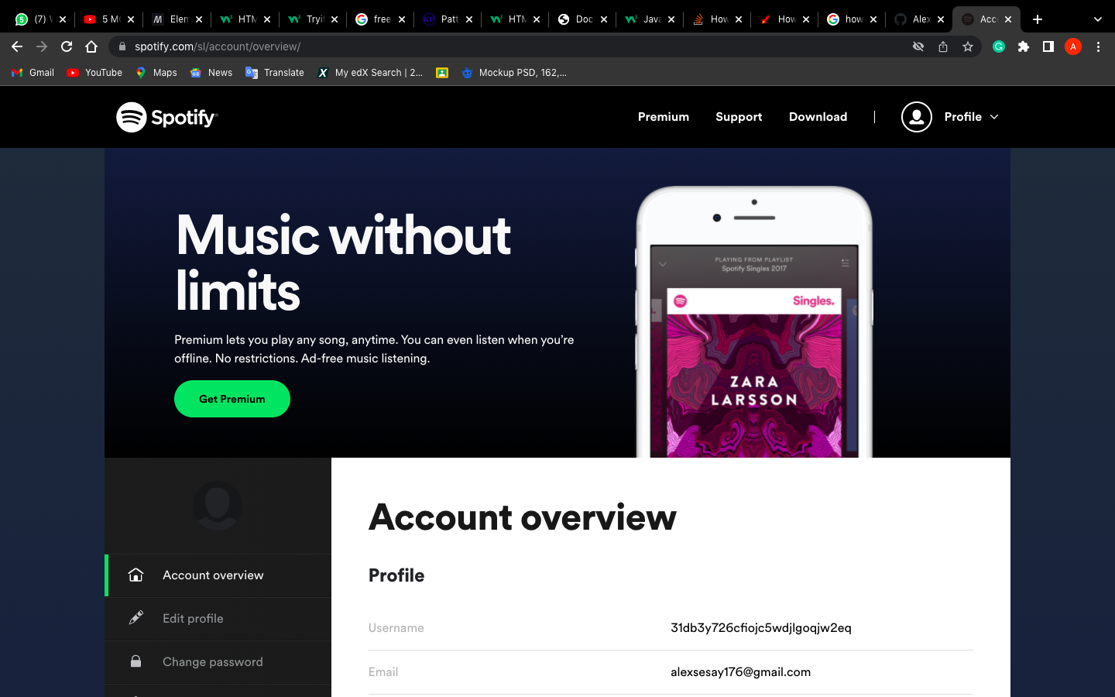

In the desktop view everything is well spaced and in a grid layout. In the nav-bar the nav-links are all written in text for better description. Then the heading text, the follow up paragraph and the get premium button are in the same row with the phone picture. And below that is another is another grid/flex row with rectangular nav-bar on the left and a rectangular display on the right.

***Tablet View:***

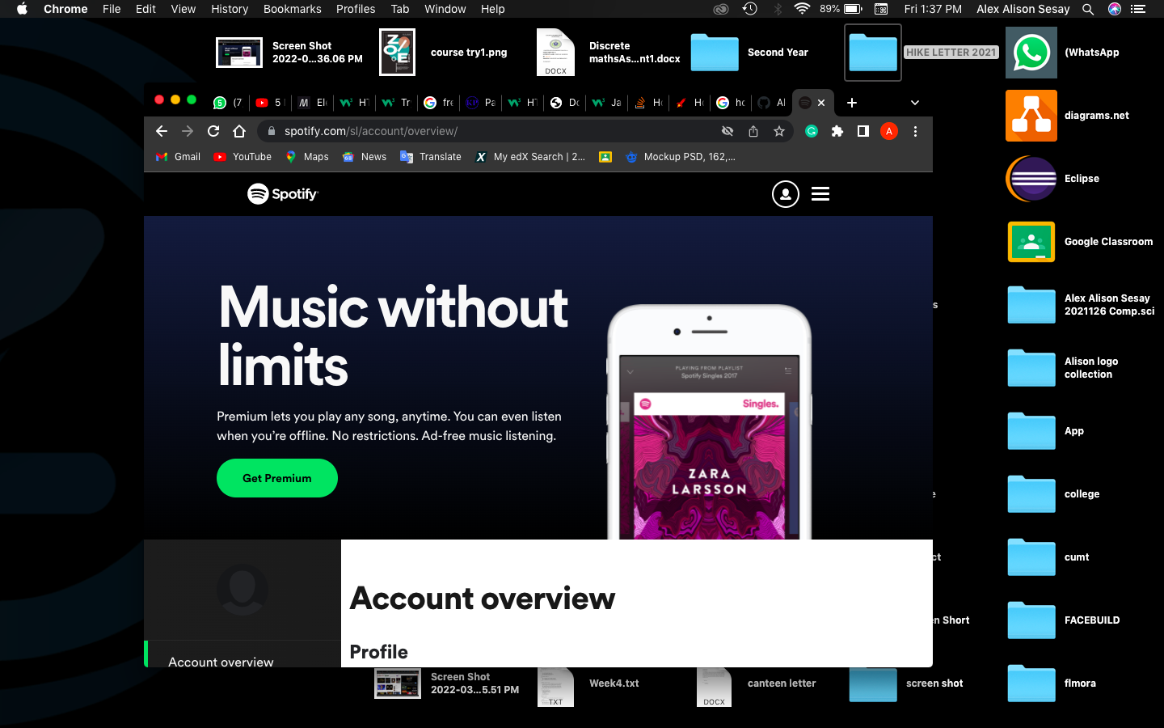

When the web is in a tab view a little of change is applied to the web nav-links. When in a tab view the nav-links text will disappear and then replace with a rectangular toggle icon with the user icon still the same when the rectangular toggle icon is clicked the text nav-link will display. All other element below will remain the same.

***Phone View:***

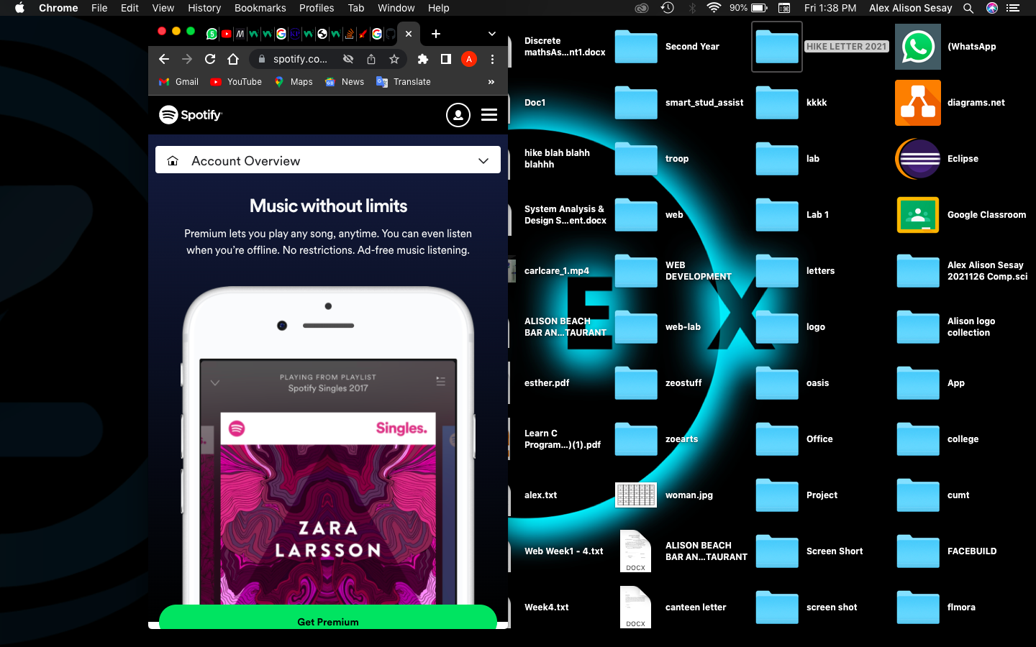

When the site is accessed in the phone the interface becomes completely different. As in the tab view the nav-link will be replaced with a rectangular toggle icon which will wrap the nav-link text within it the body of the page will be in a column layout which each element coming one after the other. After the nav-bar the header will be displayed below that the phone picture will be displayed and everything in the page follow this sequence due to the size of the device its being accessed on